Autumn 1 Mid-Term Planning – EYFS
Topic: “Marvellous Me!” (Our Brilliant Bodies)
Curriculum Values | Christian Values - Faith, Hope and Love | Learning Focus Areas for the term: | Love
Curriculum Values | Environmental Stewardship - 10 Eco- School Areas* | Learning Focus Areas for the term: | Global Citizenship/ Healthy Living/ School Grounds
Curriculum Values | Inclusive Community - School, Local or Wider | Learning Focus Areas for the term: | School and Local
Curriculum Values | Active Citizens | Learning Focus Areas for the term: | Kindness / Curiosity About the World
Curriculum Values | (*Environmental Stewardship: Biodiversity, Energy, Global Citizenship, Healthy Living, Litter, Marine, School Grounds, Transport, Waste, Water)

Key Dates
Week 1  1st – 5th Sept  (1st & 2nd Inset days)  3rd – children back | Week 2  8th – 12th Sept | Week 3  15th – 19th Sept | Week 4  22rd – 26th Sept | Week 5  29th Sept – 3th Oct  Black History Month | Week 6  6th – 10th Oct  Black History Month | Week 7  13th -17th Oct  Black History Month
5th – International Day of Charity  6th – International Read A Book Day (Bring A Book to School Day)  8th - International Literacy Day | 12th – National Video Game Day (Stem for Girls)  13th – Roald Dahl Story Day | 15th – International Day of Democracy  15th – International Dot Day  15^{th-} 21st – Jeans for Genes Day  18th Read an E-book Day  19th – Talk Like A Pirate Day  21st International Day of Peace | 22nd Equinox (Start of Fall)  22nd – 5th Fairtrade Fortnight  22nd – 28th – Week of Deaf People  21st – World Gratitude Day  22nd -24th Rosh Hashanah  22nd – 28th Recycling Week  27th – International Rabbit Day | 22nd – 5th Fairtrade Fortnight  29th – World Heart Day  National Poetry Week  1st - 2nd – Yom Kippur  4th – World Animal Day  5th - Harvest | 4th – 10th – World Space Week  5th – Grandparents’ Day  6th - World Habitat Day  6th – 13th Sukkot  8th – World Octopus Day | 15th Handwashing Day  16th World Food Day  21st Diwali  31st Halloween

Possible calendar dates to add: WK2 Welcome meetings & Opal parent day. School photos, poem performance

Key Texts
Week 1  1st – 5th Sept  (1st & 2nd Inset days)  3rd – children back | Week 2  8th – 12th Sept | Week 3  15th – 19th Sept | Week 4  22rd – 26th Sept | Week 5  29th Sept – 3th Oct | Week 6  6th – 10th Oct | Week 7  13th -17th Oct
The Bumblebear  Goat Goes to Playgroup  I Had It First!  Our Class is a Family  A Letter from Your Teacher  Pip and Posy: The New Friend  * Help! I’ve Lost My Classroom  *The Colour Monster Goes to School | The Bumblebear  Goat Goes to Playgroup  I Had It First!  Our Class is a Family  A Letter from Your Teacher  Pip and Posy: The New Friend  * Help! I’ve Lost My Classroom  *The Colour Monster Goes to School | Pete the Cat: Rocking in My School Shoes  The Dot  The Invisible String  Only One You  All About Families | Barbara Throws A Wobbler  Geoffrey Gets the Jitters  The Jar of Happiness  Freddie and The Fairy (Deaf Awareness Week) | Rain Before the Rainbows (Link to Poems?)  Find Some Poems!!! | Senses My Body, Your Body  I Hear A Pickle (And Smell, See, Touch, And Taste It Too!)  The Leaf Thief  Leaf Man  We’re Going on a Leaf Hunt | Senses My Body, Your Body  I Hear A Pickle (And Smell, See, Touch, And Taste It Too!)  The Leaf Thief  Leaf Man  We’re Going on a Leaf Hunt

Books to read throughout Autumn 1 term:
- You Choose
- You Choose Your Dreams

Yellow – Hive
Pink – Rainbow Class

Further Links
Book Links:  Only one You - Only One You Read Aloud - YouTube  All about Families - All About Families 👨‍👨‍👧‍👧👨‍👩‍👧👨🏽‍🦽👩🏾‍🤝‍👨🏻 Usborne Books is LGBTQ+ Friendly! 🏳️‍🌈 - YouTube  A jar of Happiness - Kids Read Aloud: The Jar of Happiness - ALIVE Story Time with Miss Ferreira - YouTube  I hear a pickle - I Hear a Pickle (and Smell, See, Touch, and Taste It Too!) - YouTube  Harvest Party - 📕 Kids Read Aloud : Harvest Party By Jennifer O'Connell - YouTube  Leaf Hunt - we're going on a leaf hunt - Google Search  The Leaf Thief - the leaf theif - Google Search  Leaf Man - 🍁Leaf Man (Read Aloud books for children) | Storytime Lois Ehlert Autumn Miss Jill - YouTube  Pete the Cat: Pete the Cat: Rocking in My School Shoes - YouTube  MAKATON  A year of communication: Focus on routines for Autumn 1  WEEK 1: Makaton - GOOD MORNING, GOOD MORNING! - Singing Hands - YouTube  WEEK 2: Makaton - GOOD MORNING, GOOD MORNING! - Singing Hands - YouTube  WEEK 3: letters for their names, routines such as toilet, washing hands, outside, play, snack time, lunch time  WEEK 4: body parts, senses, routines such as toilet, washing hands, outside, play, snack time, lunch time  (look, see, hear, touch, taste)  WEEK 5: families, harvest, tractor  WEEK 6: autumn, leaves, tree,  WEEK 7: autumn, leaves, tree, fruits such as orange, banana, apple, | Nursery Rhymes and Songs:  Settling in:  It's a Beautiful Day | Spring/Summer Song for Kids | The Singing Walrus - YouTube  Hello Song for Kids | Greeting Song for Kids | The Singing Walrus - YouTube  Senses:  Head shoulders knees and toes  If your happy and you know it (link to body) … touch your ears..  Five Senses song - Five Senses - The Kiboomers Kids Learning Songs For Circle Time - Body Parts Song - YouTube  Healthy living and healthy foods:  Good Foods | Healthy Foods Song for Kids | Jack Hartmann - YouTube  Fruit Song for Kids | The Singing Walrus - YouTube

Understanding the World
(Links to Science/ Geography/ History / RE in KS1/KS2)
Forest School  Key Words | Outdoors, Autumn, Harvest, Orange, Yellow, Leaves, Rustling, Wind, Breeze, Sticks, Stones, Pinecones, Conkers, Crispy, Crunch, Cold, Wet, Chirping, Acorns, Darkness, The Moon, Mud, Hibernation, Hedgehogs, Badgers, Owls, Squirrels, See, Hear, Smell, Touch, Taste
How We Celebrate? | Rosh Hashanah – Jewish  Yom Kippur - Jewish  Harvest – Christian  Sukkot & Simchat Torah – Jewish
Cultural Texts | Apples and Honey – A Rosh Hashanah story (Jonny Zucker)  Rosh Hashanah is Coming (Tracy Newman)  Harvest Party (Jennifer O'Connell)  Sammy Spider's First Sukkot (Sylvia Rouss)
The World Around Me! | Seasons: Autumn  Autumn walks.  Discuss the weather and begin to notice changes.  Explore how things work and be curious about the world around us.  Use our senses to describe our experiences.  Learning about our bodies.
Immersive Learning Opportunities | Autumn walks  Stay and Play sessions (The Hive)  Exploring real fruits and vegetables  Baking

 | Week 1  1st – 5th Sept  (1st & 2nd Inset days)  3rd – children back | Week 2  8th – 12th Sept | Week 3  15th – 19th Sept | Week 4  22rd – 26th Sept | Week 5  29th Sept – 3th Oct  Black History Month | Week 6  6th – 10th Oct  Black History Month | Week 7  13th -17th Oct  Black History Month
Maths | Settling in  Number Songs | MN – Subitising  WRM – Match, sort and compare | MN - Counting, cardinality and ordinality.  WRM – Match, sort and compare | MN – Composition  WRM – Match, sort and compare | MN – Subitising  WRM – Talk about measure and pattern | MN – Comparison  WRM – Talk about measure and pattern | MN - Counting, cardinality and ordinality.  WRM – It’s me 1,2,3
PSHE | Learning the school and class rules  Zones of regulation | Help others to feel welcome  Who… Me?! | Try to make Rainbow Class community a better place  How am I feeling today? | Think about everyone’s right to learn.  Being at school | Care about other people’s feelings  Gentle hands | Work well with others  Our rights | Choose to follow the Learning Charter  Our Responsibilities
RE | Creating hearts and talking about LOVE – Who we love? | What makes me special | Why is harvest important | Who is my friend?  Rosh Hashanah | How do Christians believe the world began?  Harvest  Yom Kippur | What is special about the natural world?  Sukkot | What and who do Christians believe is precious to God?  Simchat Torah
PE | Me and Myself  Why do we wear PE kit? | Me and Myself  My Body | Me and Myself  Parts of the body | Me and Myself  Senses | Me and Myself  On the move | Me and Myself  Can you … | Me and Myself  Favourite games!
Topic | Rules – Setting class rules and learning school rules. | Who lives in your house? Who else is in your family that don’t live in your house? | Only one you – painting stones like the fish. | How can we keep healthy? | Signs of Autumn | Using all of our senses | Diwali
Drawing Club | What is drawing club? | Not now Bernard | Three Billy Goats Gruff | Pink Panther | Superworm | Little Red Hen | Witch Hazel

Continuous Provision Ideas – Fine Motor & Maths
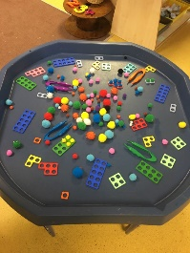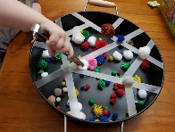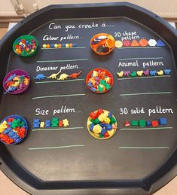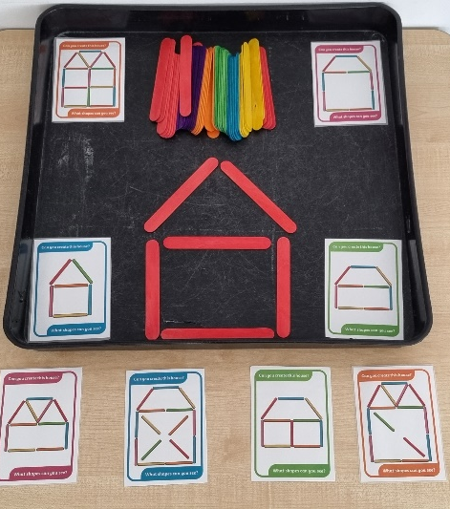
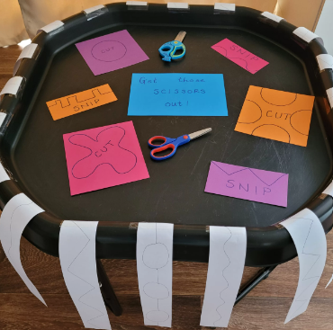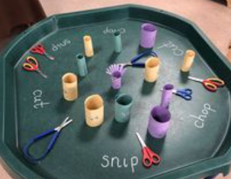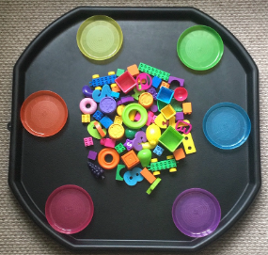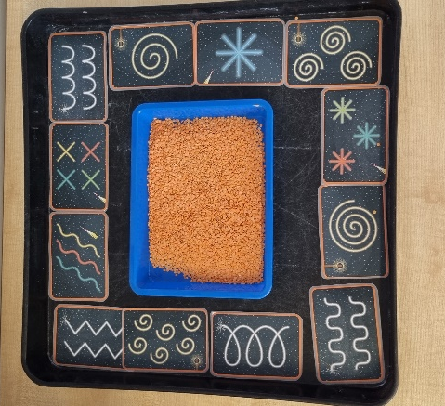
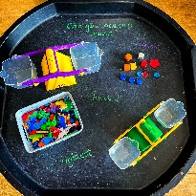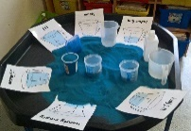

Continuous Provision – All About Me / My Body/ Faces / Senses

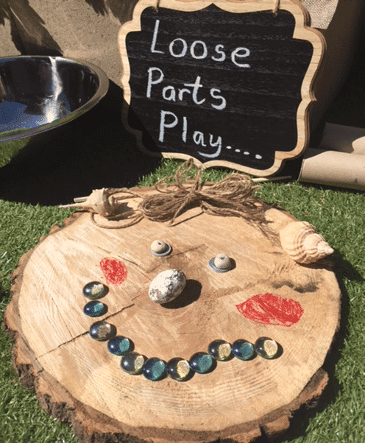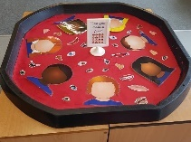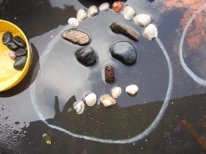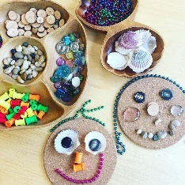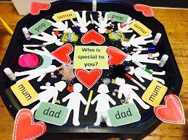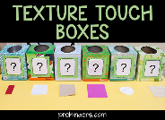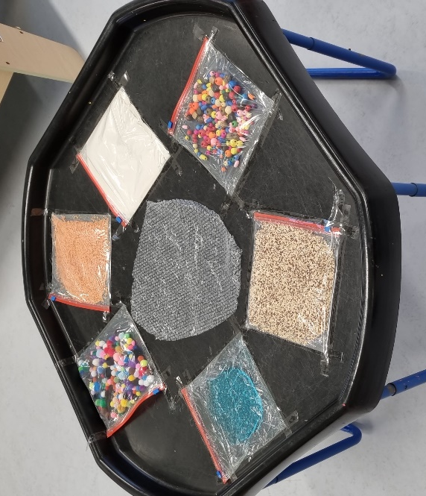

Continuous Provision – Autumn / Fruit & Veg


