2nd DECEMBER 2020
WELCOME….
We are thrilled to have become a Primary school and welcome our first KS2 children- Yes Y3- this means you!
Of course, we welcomed new teachers as a growing school and I am so pleased that Mrs Harriet Jackson and Mr Lee Armstrong have now been appointed as permanent teachers. Both have proven to be outstanding in the short time they have been with us and I’m sure your children come home buzzing!
LEADERSHIP…
Joining Harriet and Lee will be of course, your new permanent Head Teacher Mrs Alison Richardson who will be supported by Miss Donna Cobb in her role as Foundation teacher and Team Leader. Alison and Donna bring an absolute wealth of experience, care and expertise.

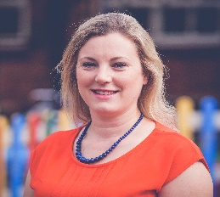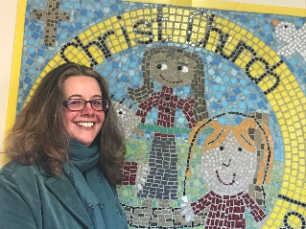
WE WISH YOU WELL …
We are sorry to be saying goodbye to Mrs Georgina Garrick and Mrs Shelley Wells. Georgina joined as our foundation teacher and we send love to her and baby Alexander.
Shelley has supported one of our young people and is leaving to do the same at another school. Thank you, Georgina and Shelley – we wish you good luck for the future!
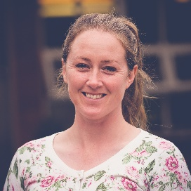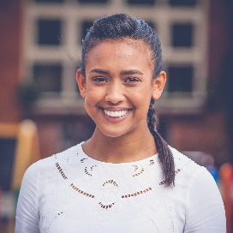
DATES FOR YOUR DIARY …
Christmas Jumper 11th December
Christmas Dinner/Party 16th December
Last day of term 18th December
INSET day 4th January
School opens 5th January
LOOK OUT FOR US…
We are excited to see such progress at the site of the new school…it is growing!
Look out for our news article in the Newark Life Magazine.
FINAL THOUGHTS…
We are entering the season of Advent and this first week encourages to have us hope. I am leaving the Christ Church family after two terms as Executive Head and it has been a pleasure and a privilege to be part of such a dedicated team and work alongside such lovely children and their families.
As we look back over an unusual year, we celebrate that we are together in school again and have hope for bright beginnings in 2021.
Take care of yourselves and each other.
KATE CUMBERPATCH

